Chapter 1:
Introduction
  - Background
Air pollution has emerged as one of the most pressing environmental and public health challenges of the twenty-first century. Driven by the compounding effects of rapid urbanization, accelerating industrial growth, expanding vehicular traffic, and widespread agricultural burning, the quality of air in both outdoor and indoor environments has deteriorated significantly across the globe. According to the World Health Organization (WHO), approximately 99% of the global population breathes air that exceeds the recommended pollutant concentration limits, making air pollution a nearly universal threat to human health and well-being. The consequences of prolonged exposure to polluted air are far-reaching and severe, encompassing a wide spectrum of respiratory and cardiovascular diseases, neurological disorders, developmental impairments in children, and a significantly elevated risk of premature mortality.
Among the most hazardous components of air pollution are fine particulate matter and harmful gaseous compounds. Particulate matter, classified by aerodynamic diameter into categories such as PM1.0, PM2.5, PM4.0, and PM10, represents a heterogeneous mixture of solid particles and liquid droplets suspended in the air. Of these, fine particles with diameters of 2.5 micrometres or less (PM2.5) are of particular concern, as their extremely small size allows them to bypass the body's natural respiratory defences and penetrate deep into the alveolar regions of the lungs. Upon reaching the bloodstream, these particles can trigger systemic inflammatory responses, exacerbate pre-existing chronic conditions, and contribute to the development of serious cardiovascular and pulmonary diseases over time. Similarly, gaseous pollutants such as volatile organic compounds (VOCs) and nitrogen oxides (NOx) are known to irritate the respiratory tract, react with other atmospheric constituents to form secondary pollutants such as ground-level ozone, and contribute to the overall degradation of indoor air quality.
While much of the public discourse around air pollution focuses on outdoor environments, indoor air quality has increasingly become a matter of equal, if not greater, concern. Studies have shown that individuals in developed and developing nations alike spend upwards of 80 to 90 percent of their time indoors, whether in residential homes, offices, schools, or healthcare facilities. Indoor environments are subject to a unique combination of pollutant sources, including cooking emissions, cleaning products, building materials, furniture outgassing, and the infiltration of outdoor pollutants through ventilation systems. In many cases, indoor pollutant concentrations can significantly exceed those measured outdoors, yet the monitoring and regulation of indoor air quality has historically received far less attention and investment than outdoor air quality management. This disparity has created a substantial gap in public awareness and personal protection, underscoring the critical need for continuous, localized, and accessible air quality monitoring systems that can deliver real-time data to the individuals who need it most.
The emergence of the Internet of Things (IoT) as a transformative technological paradigm has opened up entirely new possibilities for environmental monitoring. By enabling everyday physical devices to collect, process, and communicate data over wireless networks, IoT technology has made it feasible to design monitoring systems that are simultaneously compact, low-cost, intelligent, and connected. When applied to air quality monitoring, IoT-enabled devices can provide continuous, high-frequency measurements of multiple environmental parameters, transmit processed data to user-facing applications in real time, and empower individuals with the information they need to take timely and informed action. This project is conceived within this broader context, aiming to leverage the capabilities of modern IoT hardware and communication technologies to develop a practical, accessible, and reliable air quality monitoring solution.

  - Problem Statement
Despite the well-documented health risks associated with poor air quality, the availability of affordable, compact, and user-friendly monitoring solutions for localized indoor environments remains severely limited. The majority of air quality monitoring infrastructure that exists today falls into one of two broad categories, each with significant limitations that restrict its practical utility for individual users and small organizations.
The first category comprises large-scale, government-operated monitoring stations that are deployed at fixed locations within urban and semi-urban areas. While these stations are capable of delivering highly accurate measurements across a broad range of pollutants, they are prohibitively expensive to install and maintain, require specialized technical personnel for operation and calibration, and are typically located far from the specific indoor environments where individuals spend the majority of their time. The spatial resolution of such networks is therefore far too coarse to provide meaningful data about the air quality conditions within a particular home, classroom, or office. A monitoring station situated several kilometer away from a residential building cannot reliably capture the localized pollutant dynamics that result from indoor cooking, traffic patterns on adjacent roads, or nearby construction activity.
The second category consists of laboratory-grade analytical instruments designed for precision environmental research and regulatory compliance monitoring. These instruments, while offering exceptional accuracy and sensitivity, are bulky, expensive, power-hungry, and entirely impractical for deployment in everyday indoor settings. Their operation typically demands a controlled environment, periodic calibration against certified reference standards, and a level of technical expertise that is beyond the reach of the average user.
In between these two extremes, there exists a largely unaddressed need for monitoring solutions that are affordable enough for individual or small-scale organizational use, compact enough to be installed unobtrusively in indoor spaces, capable of measuring a comprehensive set of relevant pollutants in real time, and straightforward enough in their operation to be used without specialized training. Although a number of consumer-grade air quality monitors have entered the market in recent years, many of these devices suffer from limited sensor coverage, lack of real-time wireless data transmission, poor data accuracy, or closed software ecosystems that prevent integration with custom applications or third-party platforms. Furthermore, the absence of on-device data processing and AQI computation in many consumer products means that users are presented with raw sensor readings that are difficult to interpret without a background in environmental science. The gap between what is currently available and what is genuinely needed by end users in indoor environments forms the central problem that this project seeks to address.

  - Need and Motivation
The motivation for undertaking this project is rooted in the convergence of two complementary imperatives: the escalating public health burden of indoor air pollution, and the remarkable recent advances in low-cost sensing, embedded processing, and wireless communication technologies that now make it feasible to address this burden in a meaningful and practical way.
Air pollution-related illnesses collectively represent one of the largest contributors to the global burden of disease. Chronic obstructive pulmonary disease, asthma, lung cancer, ischemic heart disease, and stroke are among the conditions most strongly linked to prolonged exposure to airborne pollutants. Children and elderly individuals are disproportionately vulnerable, as are those with pre-existing respiratory or cardiovascular conditions. In many low- and middle-income countries, the situation is further compounded by the use of solid biomass fuels for cooking and heating, which generate extremely high concentrations of particulate matter and toxic gases within the home. Even in higher-income settings, the cumulative effect of daily exposure to moderately elevated pollutant concentrations in offices, schools, and homes represents a significant and largely invisible public health risk.
Despite this, the vast majority of individuals have no means of knowing what they are breathing at any given moment. Existing IoT-based air quality monitoring solutions, while more accessible than laboratory instruments, frequently rely on multi-node network architectures that require complex configuration, cloud-based data storage that introduces latency and privacy concerns, or communication infrastructure such as LoRa WAN or Zigbee gateways that is unavailable or impractical in typical residential or small office settings. These dependencies collectively limit the deployability of existing solutions in the resource-constrained environments where monitoring is arguably most needed.
This project is therefore motivated by the desire to develop a genuinely self-contained monitoring device that requires no external infrastructure beyond a standard Wi-Fi network, performs all data acquisition and processing on-board, and delivers real-time, interpretable air quality information directly to the user through a dedicated mobile application. By integrating all sensing, processing, and communication functions onto a single custom PCB, the system achieves a level of compactness, simplicity, and cost-effectiveness that addresses the key barriers to widespread adoption identified above.

  - Intended Audience
The air quality monitoring system developed in this project is designed to serve a diverse range of users and stakeholders who share a common interest in understanding and improving the quality of the air in their immediate environments.
At the individual and household level, the system is intended for health-conscious residents who wish to monitor the air quality within their homes, particularly in urban areas where outdoor pollution levels are high or in homes where indoor pollutant sources such as gas stoves, cleaning chemicals, or recently installed furniture may be present. Parents of young children and caregivers of elderly or immunocompromised individuals may find the system particularly valuable as a tool for proactively identifying and mitigating indoor air quality risks before they manifest as health problems.

At the institutional level, the system is applicable to educational institutions such as schools and universities, where high occupancy densities and limited ventilation can lead to elevated CO2 and VOC levels that impair cognitive performance and student well-being. Corporate offices, co-working spaces, and small businesses can similarly benefit from continuous monitoring to ensure that their indoor environments meet acceptable air quality standards and support the productivity and health of their occupants. Healthcare facilities such as clinics and outpatient centres, where vulnerable patients may be present, represent another important application domain.
Beyond end users, the system is also relevant to researchers and developers working in the fields of environmental monitoring, embedded systems design, and IoT application development. The open and modular architecture of the system makes it a suitable platform for academic experimentation, sensor evaluation, and the development of more advanced data analytics or machine learning applications built on top of real-time air quality data streams.

  - Project Scope
The scope of this project encompasses the end-to-end design, development, integration, and validation of a custom PCB-based IoT air quality monitoring system. On the hardware side, the project involves the schematic design and PCB layout of a compact, single-board device that integrates all necessary sensing, processing, power management, and wireless communication components. The system measures a comprehensive set of environmental parameters including particulate matter across four size classifications (PM1.0, PM2.5, PM4.0, and PM10), ambient temperature and relative humidity, VOC index, and NOx index, providing a holistic picture of indoor air quality that goes beyond the single-parameter measurements offered by many consumer devices.
On the firmware side, the project covers the development of embedded software responsible for sensor initialization, periodic data acquisition, signal conditioning, and real-time computation of the Air Quality Index using standard linear interpolation methods consistent with established environmental guidelines. The computed AQI values, along with all individual sensor readings, are packaged and transmitted wirelessly over Wi-Fi using the MQTT protocol, a lightweight publish-subscribe messaging protocol widely used in IoT applications for its low bandwidth overhead and suitability for resource-constrained devices.
On the application side, the project includes the development of a dedicated mobile application that subscribes to the MQTT data stream, presents real-time sensor readings and AQI values in a clear and intuitive interface, and provides users with contextual information and guidance regarding the health implications of measured pollutant levels.
It is important to note the boundaries of the project scope. The system is designed and validated for deployment in indoor and localized near-outdoor environments and is not intended to serve as a replacement for government-grade reference monitoring instruments. The project does not cover large-scale multi-node network deployment, integration with national or regional air quality databases, or regulatory compliance certification. Sensor calibration is performed against manufacturer specifications rather than certified reference standards, which is consistent with the intended use case of the system as a personal and organizational monitoring tool rather than a regulatory measurement device.

Chapter 2:
Literature Survey
This chapter reviews six key papers related to IoT-based air quality monitoring systems, each contributing a distinct perspective that shaped the design decisions of the present work. The reviewed works are presented in reverse chronological order, from the most recent to the earliest, to reflect the progression of the field and the evolving challenges that motivated this project.

  - Review of Existing Literature
Liu et al. [5] proposed a multi-point indoor air quality monitoring system based on IoT, employing multiple embedded controllers and distributed sensors deployed across various indoor locations to provide a comprehensive spatial assessment of air quality within enclosed environments. Their system demonstrated that distributing sensing nodes across different rooms or zones within a building could capture the spatial variability of indoor pollutant concentrations with a level of granularity that single-point monitoring solutions are unable to achieve. The architecture relied on coordinating data from several independent embedded nodes, each responsible for local sensing and transmission, which were then aggregated to form a unified picture of the indoor air quality landscape. While this approach proved effective in delivering detailed and spatially rich monitoring data, it simultaneously introduced significant hardware complexity and elevated deployment costs arising from the need to procure, configure, and maintain multiple sensing units. The increased node count also raised concerns about long-term reliability and the practical effort required to keep all nodes operational and properly calibrated over time. This study directly inspired the indoor application focus of the present work; however, our approach improves upon it by consolidating all sensing, processing, and communication functionality within a single compact PCB, thereby substantially reducing system complexity and cost while retaining the essential indoor monitoring capabilities demonstrated by Liu et al.
Zhang and Woo [1] presented a real-time localized air quality monitoring and prediction system that employs both mobile and fixed sensing nodes, leveraging cloud-based analytics to deliver real-time monitoring and predictive insights across urban environments. Their work effectively demonstrated the power of combining spatially distributed sensing infrastructure with cloud-based data processing to produce not only real-time pollutant concentration readings but also short-term air quality predictions that could assist users in planning their outdoor activities and exposure. The use of mobile sensing nodes, in particular, added a dynamic dimension to the monitoring network by capturing pollutant data along transit routes and in areas not covered by fixed infrastructure, thereby improving the overall spatial resolution of the system. Despite these strengths, the system's dependence on multiple sensor nodes, cloud connectivity, and the associated communication infrastructure introduces a level of complexity and external dependency that is fundamentally at odds with the goal of developing a compact, self-contained, and easily deployable monitoring solution. The real-time monitoring aspect of the present work draws direct inspiration from the approach demonstrated by Zhang and Woo [1]; however, their work also highlighted the need for a standalone, localized solution that does not rely on cloud infrastructure or multi-node coordination, motivating the decision in the present work to perform all data acquisition and AQI computation on-device and transmit results directly to a mobile application via Wi-Fi.
Hu et al. [4] designed a real-time fine-grained air quality sensing network for smart city applications, built around a multi-node architecture comprising distributed sensing units, dedicated gateways, and backend servers that collectively enabled urban-scale environmental monitoring with high spatial and temporal resolution. Their work placed a strong emphasis on network scalability, communication optimization, and the ability to handle large volumes of concurrent sensor data streams from geographically dispersed nodes, making it well-suited for city-wide deployment scenarios where monitoring coverage and data density are the primary objectives. The system's backend infrastructure supported advanced data analytics and visualization, providing city administrators and researchers with a powerful tool for understanding pollutant distribution patterns at an urban scale. However, the complexity inherent in coordinating a large multi-node network, combined with the high deployment costs associated with gateway hardware and server infrastructure, renders this approach entirely impractical for localized indoor monitoring in residential, educational, or small office environments. The present work draws a deliberate contrast with the approach of Hu et al. [4] by prioritizing simplicity, portability, and cost-effectiveness over scalability and network complexity, targeting localized monitoring scenarios where a single integrated device is sufficient to meet the monitoring needs of the environment without requiring any dedicated gateway or backend infrastructure.
Chen et al. [3] proposed an open participatory framework for PM2.5 monitoring in smart cities, in which sensing units independently deployed by ordinary citizens collectively contributed to large-scale particulate matter data collection across urban areas. The participatory model offered a compelling and innovative approach to expanding the spatial coverage of air quality monitoring networks at minimal centralized cost, leveraging the geographic distribution of citizen participants to capture pollutant data from a far wider range of locations than would be feasible with a conventionally deployed fixed sensor network. The open framework also encouraged community engagement with air quality issues and provided a low-barrier entry point for individuals to contribute to environmental data collection. However, the reliance on heterogeneous hardware platforms sourced independently by different participants introduced significant inconsistencies in sensor specifications, calibration states, and measurement methodologies, leading to variability in data quality and reliability across the network that complicated the interpretation and aggregation of the collected data. These limitations underscored the critical importance of controlled and standardized hardware integration in ensuring that measurements across a monitoring system are consistent, comparable, and trustworthy. This directly influenced the decision in the present work to develop a custom-designed PCB that brings all sensing components onto a unified, controlled hardware platform, ensuring consistency, reliability, and repeatability of measurements across all deployments of the system.
Zheng et al. [2] presented an LPWAN-based air quality monitoring system that integrated embedded controllers with environmental sensors to achieve long-range wireless communication with significantly reduced power consumption, targeting wide-area deployments where communication range and energy efficiency are the dominant design constraints. Their system demonstrated that LPWAN technologies suchas LoRa could enable sensor nodes to transmit data over distances of several kilometres on battery power alone, making the approach well-suited for outdoor monitoring in rural or semi-urban areas where conventional wireless infrastructure such as Wi-Fi is unavailable. The low power consumption characteristics of the system also made it attractive for scenarios where frequent battery replacement or wired power supply is impractical. Despite these advantages, LPWAN-based communication inherently introduces higher data transmission latency compared to Wi-Fi or Bluetooth, and the deployment of an LPWAN network requires dedicated gateway hardware that is not available in standard indoor environments. These characteristics make LPWAN a poor fit for the real-time, low-latency data delivery requirements of an indoor air quality monitoring system intended for use in homes, offices, and classrooms. The observations drawn from the work of Zheng et al. [2] directly motivated the present work to adopt a Wi-Fi based communication approach using the MQTT protocol, which provides the low latency, high data rate, and broad infrastructure availability needed to support real-time monitoring and immediate data delivery to the user's mobile application.
Kumar et al. [6] presented an air quality monitoring system developed in accordance with ISO/IEC/IEEE 21451 standards, with a strong emphasis on standardized sensor interfaces, transducer electronic data sheets, and interoperability between heterogeneous sensing devices and data acquisition platforms. Their work demonstrated that adopting established international standards for sensor communication and data formatting could significantly enhance the modularity, maintainability, and long-term compatibility of air quality monitoring systems, enabling sensors from different manufacturers to be integrated and replaced without requiring fundamental changes to the underlying system architecture. The standards-based approach also facilitated data sharing and interoperability with external systems and databases, which is of particular value in large-scale or regulatory monitoring contexts. However, adherence to comprehensive international standards frameworks often results in more complex hardware configurations, increased firmware development effort, and a degree of architectural overhead that may be disproportionate to the needs of a localized, single-device monitoring system intended for individual or small organizational use. The work of Kumar et al. [6] thus highlights an important trade-off between standardization and simplicity, motivating the present work to adopt a practical, PCB-level integration approach that balances functionality, reliability, and ease of deployment without imposing the full architectural complexity associated with standards-heavy implementations.

  - Research Gaps and Design Implications
Collectively, the reviewed works reflect the substantial progress that has been made in IoT-based air quality monitoring over the past decade, yet each system reveals persistent limitations that leave important practical needs unaddressed. The multi-node architectures of Liu et al. [5] and Hu et al. [4], while effective for spatial coverage, introduce hardware complexity and infrastructure costs that are prohibitive for individual indoor use. The cloud dependency of Zhang and Woo [1] introduces latency and external infrastructure requirements incompatible with standalone operation. The participatory model of Chen et al.[3] compromises measurement consistency through hardware heterogeneity. The LPWAN approach of Zheng et al. [2] sacrifices real-time responsiveness and indoor applicability in favour of range and energy efficiency. The standards-based design of Kumar et al. [6], while enhancing interoperability, imposes architectural overhead that is excessive for compact, localized deployment. In contrast to these large-scale networks, multi-node architectures, and standards-heavy implementations, the present work focuses on the design of a compact, PCB-based air quality monitoring system that integrates sensing, processing, and communication within a single portable device, targeting localized indoor monitoring scenarios where simplicity, deployability, and hardware integration are the primary considerations.

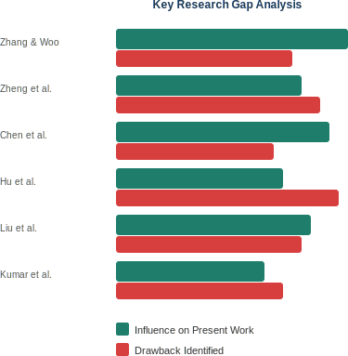
Figure 2.1 Key Research Gap Analysis

Chapter 3:
System Requirements
  - Functional Requirements
• Continuous Environmental Sensing and Data Acquisition
The system shall be capable of continuously monitoring and recording multiple environmental parameters, including particulate matter concentrations (PM1.0, PM2.5, PM4.0, PM10), ambient temperature, relative humidity, Volatile Organic Compounds (VOC) index, and Nitrogen Oxides (NOx) index. The sensing process must operate at regular intervals (e.g., every second or as configured), ensuring that real-time environmental changes are captured accurately. The system should also ensure stable sensor initialization, periodic sampling, and noise filtering to maintain reliable and consistent data acquisition over extended periods of operation. Additionally, the system should be designed to handle variations in environmental conditions without degradation in sensing performance.
• Real-Time AQI Computation Using Standardized Methods
The system shall compute the Air Quality Index (AQI) in real time using standard linear interpolation techniques based on established environmental guidelines (such as CPCB or EPA standards). This involves mapping raw pollutant concentration values to corresponding AQI categories (Good, Satisfactory, Moderate, Poor, Very Poor, Severe). The computation must be performed on-device using embedded processing to minimize latency and ensure immediate availability of results. The system should also support handling multiple pollutant inputs and determining the dominant pollutant contributing to the AQI value, ensuring accurate and meaningful representation of overall air quality.
• Wireless Data Transmission via Wi-Fi Using MQTT Protocol
The system shall transmit processed sensor data, including individual parameter readings and computed AQI values, to a remote mobile application using Wi-Fi connectivity. Communication shall be implemented using the MQTT (Message Queuing Telemetry Transport) protocol, ensuring lightweight, efficient, and reliable data transfer suitable for IoT environments. The system must establish a stable connection to a local Wi-Fi network, publish data to predefined MQTT topics, and ensure minimal latency in transmission. It should also incorporate basic error handling mechanisms such as reconnection attempts, data retransmission, and message integrity checks to maintain uninterrupted communication.
• User-Friendly Mobile Application for Data Visualization
The mobile application shall provide a clear, intuitive, and user-friendly interface for displaying real-time environmental data. It must present individual sensor readings (PM values, temperature, humidity, VOC, NOx) along with the computed AQI in an easily understandable format, such as numerical values, color-coded indicators, graphs, or charts. The application should allow users to quickly interpret air quality conditions without requiring technical knowledge. Additionally, it may include features such as historical data visualization, trend analysis, and alert notifications when pollutant levels exceed safe thresholds, thereby enhancing user awareness and enabling informed decision-making.
• Visual Power-On and System Status Indication
The system shall include an onboard LED indicator to provide a clear visual confirmation of power status and system operation. Upon powering the device, the LED should illuminate to indicate successful initialization. The indicator may also be designed to reflect different system states (e.g., blinking during data transmission, steady glow during normal operation, or specific patterns during errors), thereby assisting in basic diagnostics and improving user interaction with the device without requiring additional interfaces.

  - Non-Functional Requirements
• Compactness and Physical Integration
The system must be designed with a strong emphasis on compactness by integrating all essential components—including the microcontroller, environmental sensors, power regulation circuitry, and communication interfaces—onto a single custom-designed printed circuit board (PCB). This compact integration minimizes the overall physical footprint of the device, making it highly portable and suitable for deployment in constrained indoor environments such as homes, offices, classrooms, and laboratories. The PCB layout must be optimized to ensure efficient space utilization, proper component placement, and minimal wiring complexity, thereby improving reliability and ease of assembly. Additionally, a compact design enhances aesthetic appeal and enables seamless installation without disrupting the surrounding environment.
• Reliability and Continuous Operation
The system must demonstrate high reliability by operating continuously and consistently over extended periods under normal indoor environmental conditions. It should be capable of handling fluctuations in temperature, humidity, and air quality without performance degradation. The hardware and firmware must be designed to minimize failures, incorporating stable power regulation, robust communication protocols, and fault-tolerant programming practices. The system should also include provisions for handling unexpected conditions such as sensor read errors, communication drops, or temporary power interruptions, ensuring automatic recovery and uninterrupted operation. Long-term reliability is essential to maintain user trust and ensure accurate monitoring without frequent maintenance.
• Cost-Effectiveness and Component Selection
The overall system design must prioritize low cost by selecting affordable, readily available, and commercially viable components without significantly compromising performance. The choice of sensors, microcontroller, and supporting circuitry should balance cost and functionality to ensure that the final product remains accessible to a wide range of users, including students, households, and small organizations. The use of a custom PCB further reduces manufacturing and assembly costs by eliminating unnecessary modules and connectors. Additionally, the design should consider scalability for mass production, where bulk manufacturing can further reduce per-unit cost, making the solution economically sustainable for widespread deployment.
• Real-Time Performance and Low Latency
The system must be capable of delivering real-time performance by ensuring that environmental data is sensed, processed, and transmitted with minimal delay. Sensor readings should be updated at regular intervals, and the computed AQI values must be generated instantly using on-device processing. The communication system, based on Wi-Fi and MQTT protocol, must ensure fast and efficient data transfer to the mobile application with negligible latency. This real-time capability is critical for enabling users to respond promptly to changes in air quality, such as taking corrective actions like ventilation or reducing exposure to pollutants. The system should also be optimized to prevent data bottlenecks and ensure smooth operation even during continuous data streaming.
• Ease of Use and User Accessibility
The system must be designed with a strong focus on user-friendliness, ensuring that it can be easily operated by individuals without any technical background. The mobile application interface should be simple, intuitive, and visually clear, allowing users to understand air quality data at a glance. Complex technical information should be presented in an easily interpretable format, such as color-coded AQI levels, icons, and simple graphs. The setup process, including device connection to Wi-Fi and application pairing, should be straightforward and require minimal configuration. By prioritizing ease of use, the system ensures broader adoption and usability across diverse user groups, including students, homeowners, and non-technical professionals.

  - Hardware Requirements

S.No. | Name | Details
1. | Microcontroller | ESP32-WROOM-32
2. | Environmental Sensor | SEN55 (Sensirion)
3. | Power Supply | 5V Supply (USB or DC adapter)
4. | Display | App Interface (Software-based)
5. | Connectivity | Wi-Fi (ESP32 built-in)
6. | PCB | Custom-designed single-layer PCB (KiCad)
7. | Voltage Regulators | Onboard (on custom PCB)
Table 3.1 Hardware Requirements

  - Software Requirements

S.No. | Name | Details
1. | Operating System | Windows 10/11
2. | Platform | Android Application
3. | Development Environment | ESP IDF (Espressif IoT Development Framework)
4. | Programming Language | Embedded C, Python
5. | PCB Design Tool | KiCad EDA
6. | Communication Protocol | MQTT (Message Queuing Telemetry Transport)
Table 3.2 Software Requirements

  - Feasibility Study
• Technical Feasibility
The proposed system is technically feasible due to the use of well-established, commercially available hardware and software components that are widely supported within the embedded systems and IoT development ecosystem. The microcontroller ESP32-WROOM-32 provides sufficient computational capability along with integrated Wi-Fi functionality, enabling efficient real-time data processing and communication. The SEN55 sensor integrates multiple environmental sensing parameters into a single module, simplifying hardware design and reducing system complexity.
On the software side, the use of ESP-IDF ensures a stable and well-documented platform for firmware development. The implementation of the MQTT protocol enables efficient and lightweight communication suitable for IoT applications. The availability of extensive documentation, libraries, and community support significantly reduces development risks and ensures that the system can be successfully implemented within the defined project timeline.
• Economic Feasibility
The system is economically viable due to its low-cost design and efficient use of resources. The total Bill of Materials (BOM) cost is considerably lower than that of commercially available air quality monitoring systems, which often include expensive proprietary components and additional infrastructure. By utilizing a custom-designed PCB and integrating all functionalities into a single board, the system minimizes hardware redundancy and reduces manufacturing costs.
In addition, the project has received valuable sponsorship support from Chip IoT Embedded Solutions, which assisted in procuring essential components, facilitating PCB fabrication, and providing development resources. This sponsorship significantly reduced the financial burden on the development team and enabled the use of high-quality components while maintaining cost efficiency. In a large-scale production scenario, further cost reductions can be achieved through bulk manufacturing and optimized supply chain management, making the system highly suitable for widespread deployment.

• Operational Feasibility
The system is designed for continuous and autonomous operation, ensuring high operational feasibility in real-world environments. Once powered and connected to a Wi-Fi network, the device operates without requiring manual intervention, continuously monitoring environmental parameters and transmitting data in real time. The embedded firmware handles all core operations, including sensor data acquisition, AQI computation, and communication, ensuring smooth and reliable performance.
The mobile application provides a simple and intuitive interface, allowing users to easily interpret air quality data without requiring technical expertise. Features such as real-time updates, clear visualization, and easy navigation make the system highly user-friendly. Additionally, the system requires minimal maintenance and can be deployed across various indoor environments such as homes, offices, and educational institutions.
The support from Chip IoT Embedded Solutions also enhanced operational feasibility by ensuring access to proper tools, technical guidance, and reliable components, thereby contributing to efficient system development, testing, and deployment.

Chapter 4:
Action Plan
This chapter outlines the week-wise execution plan followed throughout the project lifecycle, from initial literature review and component selection to PCB design, firmware development, testing, and final documentation. The action plan served as a structured roadmap to ensure timely completion of all project milestones within the academic timeline.

Week/Month | Activity | Deliverable | Status
Week 1-2 | Extensive literature review of existing IoT-based air quality monitoring systems; identification of research gaps, problem statement formulation, and project scope definition. | Literature survey document | Completed
Week 3-4 | Finalization of system architecture including selection of ESP32-WROOM-32 and SEN55 sensor; preparation of Bill of Materials with cost estimation and component availability check. | Block diagram, BOM list | Completed
Week 5-6 | Creation of full PCB schematic in KiCad including microcontroller, sensor interface, power regulation circuit, pin headers, bootloader pins, and TTL communication pins. | Schematic diagram | Completed
Week 7-8 | PCB layout design with component placement optimization, signal routing, power trace sizing, and design rule check (DRC) for manufacturability. | PCB layout files | Completed
Week 9-10 | Submission of PCB Gerber files to manufacturer; simultaneous procurement of all electronic components including ESP32, SEN55, regulators, and passive components. | Fabricated PCB | Completed
Week 11-12 | Soldering and assembly of all components on the fabricated PCB; basic continuity testing, power-on verification, and initial sensor communication check. | Assembled hardware | Completed
Week 13-14 | Development of ESP-IDF based firmware including sensor initialization, digital data acquisition from SEN55, error handling, and validation logic for incoming sensor readings. | Working firmware | Completed
Week 15-16 | Implementation of AQI computation using linear interpolation formula; integration of Wi-Fi connectivity and MQTT client for real-time data publishing to predefined topics. | Data transmission working | Completed
Week 17-18 | Design and development of Android mobile application with MQTT subscription, real-time data parsing, and user interface for displaying PM values, environmental parameters, and AQI. | Android application | Completed
Week 19-20 | Systematic experimentation across five controlled environments (baseline, empty box, 1 agarbatti, 5 agarbatti, crowded and uncrowded indoor spaces); data sampling and tabulation. | Experimental data tables | Completed
Week 21-22 | Compilation and writing of complete project report covering all chapters as per WPU format; preparation of figures, result tables, and references. | Project report | Completed
Week 23-24 | Final review of report and hardware; preparation of presentation slides covering objectives, methodology, results, and conclusions for oral evaluation. | Final presentation | In Progress

Table 4.1 Action Plan
Chapter 5:
Proposed Work

  - Problem Definition
The problem addressed by this project is the lack of an affordable, compact, and easily deployable real-time air quality monitoring solution specifically designed for localized indoor and near-outdoor environments. With the increasing levels of air pollution in urban and semi-urban regions, there is a growing need for continuous monitoring of environmental parameters at a micro-level, particularly in spaces where individuals spend the majority of their time, such as homes, offices, classrooms, and healthcare facilities.
Existing air quality monitoring systems available in the market largely fall into two extremes. On one end, there are government-operated and industrial-grade monitoring stations that provide highly accurate and comprehensive data. However, these systems are expensive, bulky, and require specialized infrastructure, making them unsuitable for personal or small-scale use. On the other end, consumer-grade devices are available, but they often suffer from limitations such as reduced accuracy, limited parameter sensing, lack of real-time processing, and restricted connectivity features. Many of these devices also operate within closed ecosystems, limiting their flexibility and integration with custom applications.
Furthermore, most existing solutions do not adequately address the need for localized monitoring. Air quality can vary significantly within small distances due to indoor activities such as cooking, cleaning, or ventilation differences. Large-scale monitoring systems fail to capture these variations, resulting in a lack of actionable insights for individuals. Additionally, systems that rely heavily on cloud infrastructure introduce latency, privacy concerns, and dependency on external networks, which may not always be reliable or accessible.
Another critical challenge lies in the complexity and deployment difficulty of current solutions. Many systems require multiple sensors, external modules, or additional gateways, leading to increased hardware complexity, higher power consumption, and difficult installation processes. This creates a barrier for non-technical users who require simple and effective monitoring tools.
To address these challenges, the proposed solution focuses on developing a compact, cost-effective, and self-contained air quality monitoring system by integrating sensing, data processing, and wireless communication capabilities onto a single custom-designed PCB. This approach eliminates the need for bulky external modules and reduces system complexity while maintaining functionality. The system is designed to provide real-time monitoring and immediate feedback to users through a mobile application, ensuring accessibility, ease of use, and practical deployment in everyday environments.
By bridging the gap between high-cost professional systems and limited consumer devices, this project aims to deliver a balanced solution that is technically efficient, economically viable, and user-friendly, thereby enabling individuals and small organizations to monitor and improve their indoor air quality effectively.
Problem Definition:
Existing air quality monitoring systems are often expensive, bulky, or lack real-time localized sensing, making them unsuitable for personal or indoor use. There is a need for a low-cost, compact, and IoT-enabled solution that can accurately monitor multiple environmental parameters and provide real-time, accessible air quality insights.

  - Features
• Multi-Parameter Environmental Sensing
The system is designed to monitor a wide range of critical air quality parameters simultaneously, providing a comprehensive understanding of the surrounding environment. It measures particulate matter across multiple size ranges, including PM1.0, PM2.5, PM4.0, and PM10, which are essential indicators of air pollution and directly impact human health. In addition to particulate matter, the system also captures ambient temperature and relative humidity, which influence pollutant behavior and indoor comfort levels. Furthermore, the inclusion of Volatile Organic Compounds (VOC) index and Nitrogen Oxides (NOx) index enables detection of harmful gaseous pollutants commonly produced by indoor activities such as cooking, cleaning, and combustion processes. By integrating all these parameters into a single system, the device provides a holistic and accurate representation of air quality conditions.
• On-Device AQI Computation
The system performs real-time Air Quality Index (AQI) computation directly on the embedded hardware, eliminating the need for external processing or cloud-based calculations. Using standard linear interpolation methods based on established environmental guidelines, the system converts raw pollutant concentration values into a single, easy-to-understand AQI value. This on-device processing ensures minimal latency, immediate availability of results, and improved reliability even in the absence of continuous internet connectivity. It also enhances data privacy, as raw sensor data does not need to be transmitted to external servers for processing.
• Wireless Communication via Wi-Fi and MQTT Protocol
The system utilizes built-in Wi-Fi capabilities to enable seamless wireless communication with external devices. Data transmission is implemented using the MQTT (Message Queuing Telemetry Transport) protocol, which is specifically designed for lightweight and efficient communication in IoT applications. The system publishes sensor readings and AQI values to predefined topics, allowing the mobile application to subscribe and receive updates in real time. This approach ensures low bandwidth usage, reduced power consumption, and reliable message delivery, even in networks with limited resources.
• Real-Time Mobile Application Interface
A dedicated mobile application is developed to provide users with real-time access to air quality data. The application displays sensor readings and AQI values in a clear, intuitive, and user-friendly format, using visual elements such as graphs, color-coded indicators, and numerical values. Users can monitor changes in air quality instantly and gain insights into environmental conditions without requiring technical expertise. The interface may also support additional features such as historical data tracking, alerts, and trend analysis, enhancing user awareness and enabling informed decision-making.
• Custom Single-Board PCB Design
The entire system is implemented on a custom-designed single-layer PCB, ensuring compactness and efficient integration of all components. The PCB incorporates the microcontroller, sensor interfaces, power regulation circuitry, boot configuration pins, and TTL communication interfaces required for programming and debugging. Careful PCB design practices, such as proper routing, grounding, and component placement, are followed to ensure signal integrity, noise reduction, and reliable operation. This integrated design eliminates the need for external modules and reduces overall system complexity.
• Integrated Power Management and Status Indication
The system includes onboard voltage regulation to ensure stable power supply to all components, protecting them from voltage fluctuations and ensuring consistent performance. A power-on LED indicator is integrated into the PCB to provide immediate visual confirmation of system status. This indicator helps users verify that the device is functioning correctly and can also assist in basic troubleshooting during operation.
• Low-Cost, Compact, and Portable Design

The system is designed with a strong focus on affordability, compactness, and portability. By integrating all functionalities into a single PCB and selecting cost-effective components, the overall system cost is kept significantly lower than that of commercial air quality monitoring devices. The compact form factor allows the device to be easily installed in various indoor environments without occupying significant space. Its portability enables users to relocate the device as needed, making it suitable for diverse applications such as homes, offices, classrooms, and small industrial spaces.

Figure 5.1 System Features

  - Goal / Aim
The primary goal of this project is to design, develop, and validate a compact printed circuit board (PCB)-based Internet of Things (IoT)-enabled air quality monitoring system capable of providing accurate, real-time, and actionable environmental data to end users in localized indoor and near-outdoor settings. The system is intended to address the growing need for accessible and continuous air quality monitoring solutions that can be easily deployed in everyday environments without requiring specialized infrastructure or technical expertise.
A key objective of this project is to demonstrate that multiple functional components—namely environmental sensing, embedded data processing, and wireless communication—can be effectively integrated into a single, unified hardware platform. By consolidating these functionalities onto a custom-designed PCB, the system minimizes hardware complexity, reduces the need for external modules and wiring, and enhances overall reliability and portability. This integration also contributes to a reduction in system cost, making the solution more affordable and suitable for widespread adoption.
Another important aim is to ensure that the system delivers real-time performance, enabling users to receive immediate feedback on air quality conditions. Through on-device processing and efficient wireless communication, the system provides timely information that can help users take proactive measures to improve their environment, such as increasing ventilation or reducing exposure to pollutants. The computation of the Air Quality Index (AQI) further simplifies complex sensor data into an easily understandable format, enhancing usability and decision-making.
The project also seeks to develop a user-friendly interface in the form of a mobile application, allowing users to visualize environmental data in a clear and intuitive manner. By presenting information through graphical representations, color-coded indicators, and real-time updates, the system ensures accessibility for individuals without a technical background.
Furthermore, the system is designed to serve as a practical and versatile tool for improving environmental awareness across a wide range of applications. These include residential homes, where users can monitor indoor air quality for health and comfort; educational institutions, where maintaining good air quality can support student performance and well-being; corporate offices, where it can enhance productivity and employee health; and healthcare facilities, where air quality plays a critical role in patient safety.
In addition to its immediate practical applications, the project also aims to provide a scalable and extensible platform that can be further enhanced with additional features such as data analytics, cloud integration, or machine learning-based prediction models. This makes the system not only a functional product but also a foundation for future research and development in the field of smart environmental monitoring.
Overall, the goal of this project is to bridge the gap between complex, high-cost monitoring systems and limited consumer-grade devices by delivering a balanced solution that is efficient, affordable, user-friendly, and suitable for real-world deployment.

Chapter 6:
System Description
  - Block Diagram
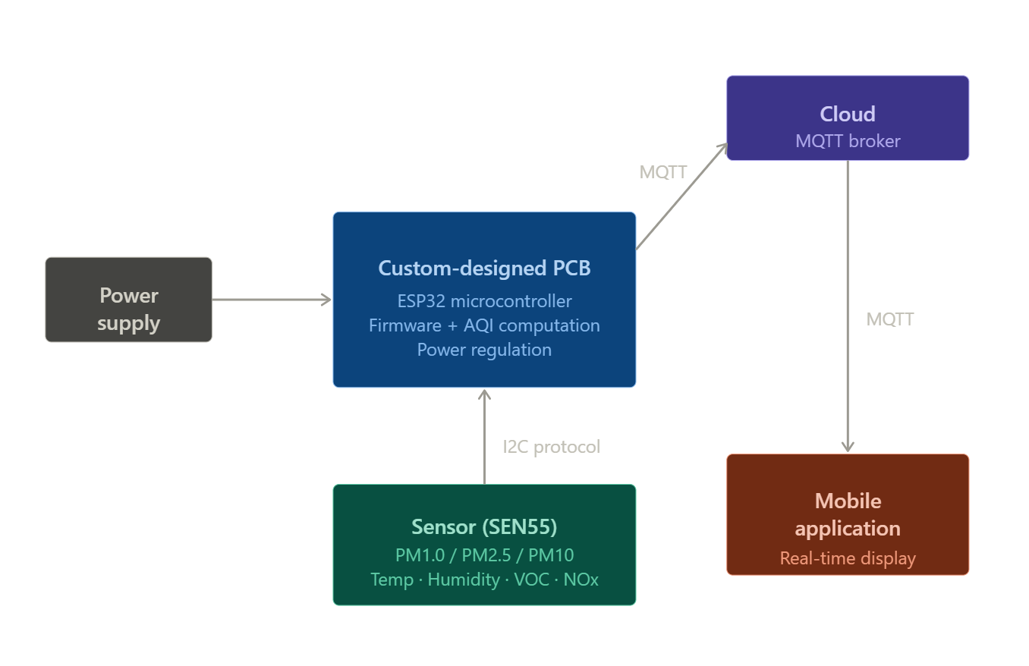
The proposed system is structured around three primary functional blocks: the Sensing Unit, the Processing Unit, and the Communication Unit. These blocks work together in a coordinated manner to acquire environmental data, process it into meaningful information, and transmit it to the end user in real time.

Figure 6.1 System Architecture
6.1.1 Sensing Unit:
It is built around the SEN55 environmental sensor, which is capable of measuring multiple air quality parameters within a single compact module. This unit continuously monitors particulate matter concentrations across different size ranges (PM1.0, PM2.5, PM4.0, and PM10), along with ambient temperature, relative humidity, Volatile Organic Compounds (VOC) index, and Nitrogen Oxides (NOx) index. The sensor internally processes raw environmental signals and provides calibrated digital outputs through a communication interface such as I2C. This eliminates the need for external signal conditioning circuits and ensures accurate and reliable data acquisition.
6.1.2 Processing Unit:
It is implemented using the ESP32-WROOM-32 microcontroller, which serves as the central control and computation module of the system. This unit is responsible for initializing the sensor, periodically collecting data, and performing necessary data processing operations. One of its key functions is the real-time computation of the Air Quality Index (AQI) using standard linear interpolation methods based on pollutant concentration levels. The microcontroller also formats the processed data into structured packets suitable for transmission. Due to its high processing capability and integrated peripherals, the ESP32 efficiently manages multitasking operations such as sensor interfacing, AQI calculation, and wireless communication simultaneously.
6.1.3 Communication Unit:
It utilizes the built-in Wi-Fi capability of the ESP32 along with the MQTT protocol to enable seamless wireless data transmission. Once the data is processed, it is published to specific MQTT topics over a Wi-Fi network. This ensures lightweight, fast, and reliable communication between the device and the mobile application. The MQTT protocol follows a publish-subscribe model, which allows the mobile application to receive updates in real time without continuously requesting data, thereby optimizing bandwidth usage and improving system efficiency.
The overall system operation follows a continuous loop in which the sensing unit captures environmental data, the processing unit computes the AQI and prepares the data, and the communication unit transmits the information to the user interface. The mobile application, acting as the end-user interface, receives this data and presents it in a visually intuitive format, allowing users to monitor air quality conditions instantly.
This modular architecture ensures that each functional block operates efficiently while maintaining seamless integration with the others. It also enhances system scalability, allowing future upgrades such as additional sensors, cloud integration, or advanced analytics without major modifications to the existing design. Overall, the design achieves a balance between performance, compactness, and ease of deployment, making it highly suitable for real-time indoor air quality monitoring applications.
  - Module Description
SEN55 Environmental Sensor Module:
The environmental sensing functionality of the system is implemented using the SEN55, a highly integrated multi-parameter sensor designed for accurate indoor air quality monitoring. This sensor is capable of measuring particulate matter across multiple size ranges, including PM1.0, PM2.5, PM4.0, and PM10, within a concentration range of 0 to 1000 µg/m³. These measurements are critical for assessing the presence of fine airborne particles that can penetrate the respiratory system and impact human health.
In addition to particulate matter, the sensor also measures ambient temperature within a range of -10°C to +60°C with a typical accuracy of ±0.5°C, and relative humidity within a range of 0 to 90% RH with an accuracy of ±3% RH. These parameters are essential for understanding environmental comfort as well as the behavior and dispersion of pollutants in indoor environments. Furthermore, the sensor internally computes Volatile Organic Compounds (VOC) index and Nitrogen Oxides (NOx) index using proprietary algorithms, eliminating the need for separate gas sensors.
The SEN55 provides fully calibrated digital outputs and communicates with the microcontroller via a standard I2C interface, ensuring reliable and noise-resistant data transmission. Its compact form factor, combined with integrated sensing capabilities, significantly reduces system complexity, improves accuracy, and simplifies hardware integration.

Hardware Interface Specifications
The sensor is equipped with a serial communication interface. The interface connector is located at the side of the sensor adjacent to the air outlet. The used connector is ACES 51451-0060N-001 on the sensor’s side, while the corresponding plug is ACES 51452-006H0H0-001. At the time of writing JST GHR-06V-S is compatible and can be used as well. A description of the pin layout is given.

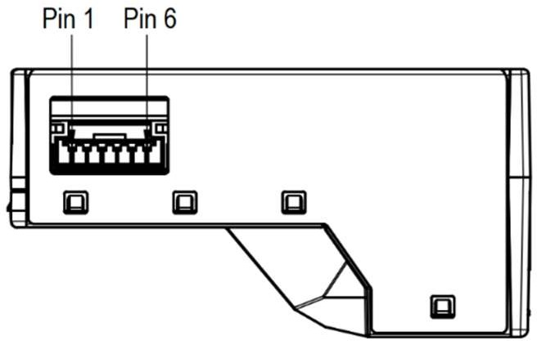
Pin | Name | Description | Comments
1 | VDD | Supply voltage | 5V ± 10%
2 | GND | Ground
3 | SDA | Serial data input / output | LVTTL 3.3V  compatible
4 | SCL | Serial clock input | LVTTL 3.3V  compatible
5 | SEL | Interface select | Connect to GND
6 | NC | Do not connect

Figure 6.2: Pin layout. The communication interface connector (ACES 51451-0060N-001) is located at the side of the sensor adjacent to the air outlet.
Table 6.1 SEN5x pin assignment.

ESP32-WROOM-32 Microcontroller Module:
The processing unit of the system is built around the ESP32-WROOM-32 microcontroller, which serves as the central control and computational core. This module features a powerful dual-core processor operating at frequencies of up to 240 MHz, enabling efficient execution of multiple tasks simultaneously. It is equipped with integrated Wi-Fi (IEEE 802.11 b/g/n) and Bluetooth capabilities, making it highly suitable for IoT-based applications.
The ESP32 is responsible for initializing and interfacing with the sensor module, periodically acquiring environmental data, and performing necessary data processing operations. A key function of the microcontroller is the real-time computation of the Air Quality Index (AQI) using standard linear interpolation techniques. It also organizes the processed data into structured formats suitable for transmission over the network.
In addition to processing, the ESP32 manages wireless communication using Wi-Fi and the MQTT protocol, ensuring efficient and low-latency data transfer. Its low power consumption, high processing capability, and rich set of peripherals make it an ideal choice for embedded air quality monitoring systems.
Power Supply Unit:
The power supply unit is designed to provide stable and regulated voltage levels required for the proper functioning of all system components. It delivers both 3.3V and 5V outputs using onboard voltage regulators integrated into the custom PCB. The 3.3V supply is primarily used for powering the microcontroller and logic circuits, while the 5V supply supports components such as the environmental sensor.
This unit ensures consistent operation even under varying input voltage conditions, protecting sensitive components from voltage fluctuations and noise. Proper filtering and regulation techniques are implemented to minimize ripple and ensure clean power delivery, which is critical for maintaining sensor accuracy and reliable system performance. The inclusion of onboard power management eliminates the need for external power modules, contributing to the compactness and portability of the system.
Custom PCB:
The entire system is implemented on a custom-designed printed circuit board (PCB), developed using KiCad EDA. The PCB integrates all hardware components, including the microcontroller, sensor interfaces, power supply circuitry, and communication pathways, into a single compact layout. This integration significantly reduces wiring complexity, enhances reliability, and improves overall system organization.
The PCB includes dedicated pin headers for the sensor module, ensuring secure and efficient connectivity. Bootloader pins are provided to facilitate firmware uploading and system programming, while TTL communication pins allow for debugging and serial monitoring during development and testing. Careful attention is given to PCB layout design, including proper grounding, trace routing, and component placement, to ensure signal integrity and minimize electromagnetic interference.
Additionally, the PCB incorporates a power-on LED indicator that provides a visual confirmation of system status. The custom PCB design not only enhances system performance but also makes the device more compact, robust, and suitable for real-world deployment.
Mobile Application:
The system includes a self-developed Android-based mobile application that serves as the primary user interface for monitoring air quality data. The application connects to the device via Wi-Fi and subscribes to MQTT topics to receive real-time data transmitted by the system. It displays environmental parameters such as particulate matter levels, temperature, humidity, VOC index, NOx index, and the computed AQI in a clear and intuitive format.
The user interface is designed to be simple and user-friendly, allowing individuals without technical expertise to easily interpret the data. Visual elements such as graphs, charts, and color-coded indicators may be used to represent air quality levels effectively. The application may also support additional features such as historical data tracking, trend analysis, and alert notifications when pollutant levels exceed safe thresholds.
By providing real-time insights and easy accessibility, the mobile application plays a crucial role in enhancing user awareness and enabling proactive measures to improve indoor air quality.
  - Advantages
• Compact and Portable Design
The system is designed with a high level of integration, combining sensing, processing, and communication functionalities onto a single custom PCB. This compact architecture significantly reduces the overall size of the device, making it highly portable and easy to deploy in various indoor environments. The absence of bulky external modules and excessive wiring enhances both reliability and ease of installation, allowing the system to be conveniently placed in homes, offices, classrooms, or laboratories without occupying significant space.
• Cost-Effective Solution
Compared to commercially available air quality monitoring systems, which are often expensive due to proprietary components and complex infrastructure, the proposed system offers a significantly lower-cost alternative. By utilizing affordable, widely available components and integrating them into a single PCB, the overall Bill of Materials (BOM) is minimized. This cost-effectiveness makes the system accessible to a broader range of users, including students, households, and small organizations, thereby promoting wider adoption of air quality monitoring solutions.
• Real-Time Data Access and Visualization
The system provides real-time access to environmental data through a dedicated mobile application. Users can instantly view air quality parameters such as particulate matter levels, temperature, humidity, VOC index, NOx index, and the computed AQI. The application presents this data in a clear and user-friendly format, enabling quick interpretation without requiring technical expertise. Real-time monitoring allows users to take immediate corrective actions, such as improving ventilation or reducing exposure to pollutants.
• Standalone Operation without External Infrastructure
One of the key advantages of the system is its ability to operate independently without requiring external servers, cloud platforms, or complex network infrastructure. All data processing, including AQI computation, is performed locally on the device, and communication is handled directly via Wi-Fi using lightweight protocols. This reduces system dependency on external resources, improves reliability, minimizes latency, and enhances data privacy, making it suitable for localized indoor monitoring applications.
• Comprehensive Multi-Parameter Monitoring
The system is capable of monitoring multiple environmental parameters simultaneously, providing a holistic assessment of air quality. By combining particulate matter measurements with temperature, humidity, VOC, and NOx indices, the system offers a more complete understanding of environmental conditions compared to single-parameter devices. This comprehensive approach enables users to identify various sources of pollution and better understand the overall impact on health and comfort.
  - Disadvantages
• Dependence on Wi-Fi Connectivity
The system relies on Wi-Fi for data transmission to the mobile application, which limits its functionality in environments where a stable wireless network is unavailable or unreliable. In such cases, real-time monitoring and data access may be interrupted. This dependency restricts deployment in remote or infrastructure-limited areas where internet connectivity is not consistently available.
• Sensor Drift over Time
Although the sensors used in the system are factory-calibrated, their accuracy may degrade over extended periods due to environmental exposure, aging, or contamination. This phenomenon, known as sensor drift, can lead to gradual deviations in measurement accuracy. Without periodic recalibration against reference standards, the reliability of long-term data may be affected, which is a common limitation in low-cost sensing systems
• Lack of Onboard Display
The system does not include a dedicated onboard display for directly viewing air quality data. As a result, users must rely on the mobile application to access real-time readings and AQI values. While this approach reduces hardware complexity and cost, it may be inconvenient in situations where immediate access to data is required without a smartphone or external device.
• Not Suitable for Regulatory or Reference-Grade Monitoring
The system is not calibrated against high-precision, government-grade air quality monitoring instruments and therefore may not meet the stringent accuracy requirements for regulatory or scientific applications. While it is highly effective for personal and localized monitoring, it should not be used as a substitute for certified environmental monitoring equipment used in official data collection or compliance reporting.
Chapter 7:
Software Design
  - Firmware Logic and AQI Computation
The firmware for the proposed system is developed using the ESP-IDF in Embedded C, providing a robust and efficient platform for programming the ESP32-WROOM-32 microcontroller. The firmware is designed to manage all core functionalities of the system, including sensor interfacing, data acquisition, processing, AQI computation, and wireless communication.
The ESP32 interfaces with the SEN55 through a digital communication bus (I2C), enabling reliable and high-speed data exchange. The firmware periodically reads environmental parameters such as PM1.0, PM2.5, PM4.0, PM10, ambient temperature, relative humidity, VOC index, and NOx index. These readings are obtained at fixed time intervals (typically every second) to ensure continuous real-time monitoring of air quality conditions.
To ensure data accuracy and stability, the firmware may incorporate basic filtering and validation mechanisms, such as checking for invalid or out-of-range values and handling sensor communication errors. The collected data is then stored temporarily in memory for further processing.
A critical component of the firmware is the computation of the Air Quality Index (AQI), which converts raw pollutant concentration values into a standardized and easily interpretable index. The AQI is calculated using the standard linear interpolation formula:
$$AQI=\left(\frac{I_{2}-I_{1}}{B_{2}-B_{1}}\right)(P-B_{1})+I_{1}$$
In this equation, P represents the measured pollutant concentration, B₁ and B₂ denote the lower and upper breakpoint concentrations corresponding to a specific AQI category, and I₁ and I₂ represent the AQI values associated with those breakpoints. These breakpoint values are defined according to standard air quality guidelines, such as those provided by environmental regulatory agencies.
The firmware computes individual AQI sub-indices for each pollutant parameter, particularly focusing on particulate matter concentrations such as PM2.5 and PM10, which are primary contributors to air quality degradation. Once all sub-indices are calculated, the system selects the maximum (worst-case) sub-index as the final AQI value. This approach ensures that the most critical pollutant determines the overall air quality classification, aligning with standard AQI calculation methodologies.
After computation, the processed data—including raw sensor readings and the final AQI value—is structured into data packets. These packets are then prepared for transmission using the MQTT over Wi-Fi. The firmware ensures efficient memory management and task scheduling to handle simultaneous operations such as data acquisition, processing, and communication without delays.
Overall, the firmware architecture is designed to be modular, efficient, and reliable, enabling real-time performance while maintaining low resource consumption. This ensures that the system delivers accurate and timely air quality information to the end user through the connected mobile application.

  - Wi-Fi and MQTT Communication
The communication functionality of the system is implemented using the built-in Wi-Fi capabilities of the ESP32-WROOM-32 microcontroller, enabling seamless wireless connectivity with external devices. Upon system startup, the firmware initiates a Wi-Fi connection process, wherein the ESP32 scans for available networks and connects to a predefined local Wi-Fi network using stored credentials. This automatic connection mechanism ensures ease of deployment and eliminates the need for repeated manual configuration.
Once a stable network connection is established, the system initializes an MQTT client using the ESP-IDF. The client is configured to connect to a designated MQTT broker, which acts as an intermediary for message exchange between the device and the mobile application. The connection process includes authentication (if required), session establishment, and subscription/publication setup, ensuring reliable communication.
The system utilizes the MQTT, a lightweight messaging protocol specifically designed for resource-constrained IoT devices. MQTT operates on a publish-subscribe architecture, where the ESP32 acts as a publisher that sends data to specific topics, and the mobile application acts as a subscriber that receives updates from those topics. This model eliminates the need for continuous polling and significantly reduces network overhead.
Sensor readings, along with computed AQI values, are packaged into structured data formats (such as JSON) and published to predefined MQTT topics at regular intervals. These intervals are carefully selected to balance real-time performance and network efficiency, ensuring that users receive timely updates without excessive data transmission. The use of MQTT Quality of Service (QoS) levels can further enhance reliability by ensuring that messages are delivered at least once or exactly once, depending on the configuration.
To maintain a stable connection, the system implements mechanisms such as periodic keep-alive messages, automatic reconnection attempts in case of network failure, and error handling routines to manage communication disruptions. This ensures continuous data flow even in environments with intermittent connectivity.
The selection of MQTT as the communication protocol offers several advantages, including low bandwidth consumption, minimal power usage, and efficient message delivery. Its lightweight nature makes it ideal for embedded systems like the ESP32, where computational and memory resources are limited. Additionally, the protocol’s scalability allows for future expansion, such as integration with cloud platforms or multiple subscriber devices.
Overall, the Wi-Fi and MQTT-based communication framework enables fast, reliable, and efficient real-time data transmission, forming a critical link between the hardware system and the user interface provided by the mobile application.

7.3 System Operation Algorithm
The firmware of the system operates based on a structured and continuous execution algorithm that ensures reliable data acquisition, processing, and communication. The entire process is designed to function in a cyclic manner, enabling real-time monitoring of environmental parameters with minimal delay and high efficiency. The following steps describe the operational workflow in detail:
• Step 1: System Initialization
• Step 2: Wi-Fi and MQTT Connection Setup
• Step 3: Continuous Sensor Data Acquisition
• Step 4: Data Validation and Filtering
• Step 5: Data Processing and AQI Computation
• Step 6: Data Packaging and Transmission
• Step 7: Controlled Delay and Loop Execution
Overall, this algorithm ensures a stable, efficient, and real-time operation of the system. Its cyclic structure allows for continuous monitoring, while its modular design enables easy scalability and future enhancements such as additional sensors, advanced filtering techniques, or cloud integration.

7.4 Mobile Application Design
The mobile application for the proposed system is developed for the Android platform, providing a convenient and accessible interface for users to monitor real-time air quality data. It serves as the primary user interaction layer, enabling seamless visualization of environmental parameters captured and processed by the embedded system.
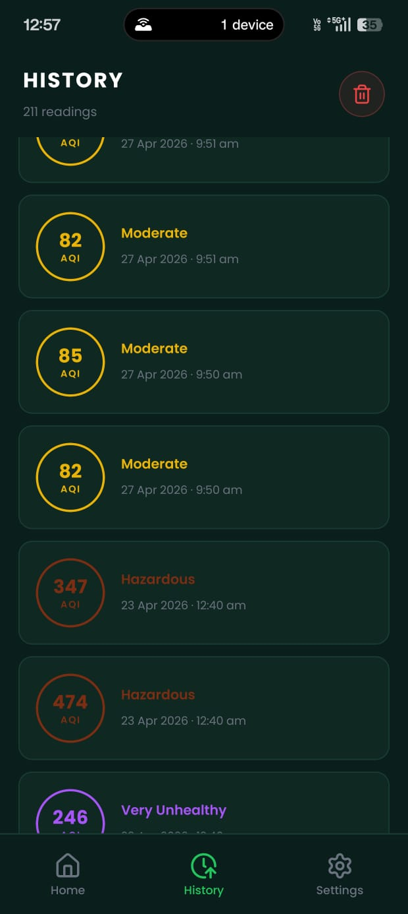
The application is designed to communicate with the ESP32-WROOM-32 device using the MQTT. Upon launch, the application establishes a connection with the MQTT broker and subscribes to predefined topics where the ESP32 publishes sensor data. This subscription-based mechanism allows the application to receive updates automatically whenever new data is transmitted, ensuring real-time synchronization without the need for manual refresh or continuous polling.
The incoming data packets, typically structured in lightweight formats such as JSON, contain detailed information about particulate matter concentrations (PM1.0, PM2.5, PM4.0, PM10), ambient temperature, relative humidity, VOC index, NOx index, and the computed Air Quality Index (AQI). The application parses these data packets efficiently and renders the information on a visual dashboard.
Figure 7.1 Mobile Application History
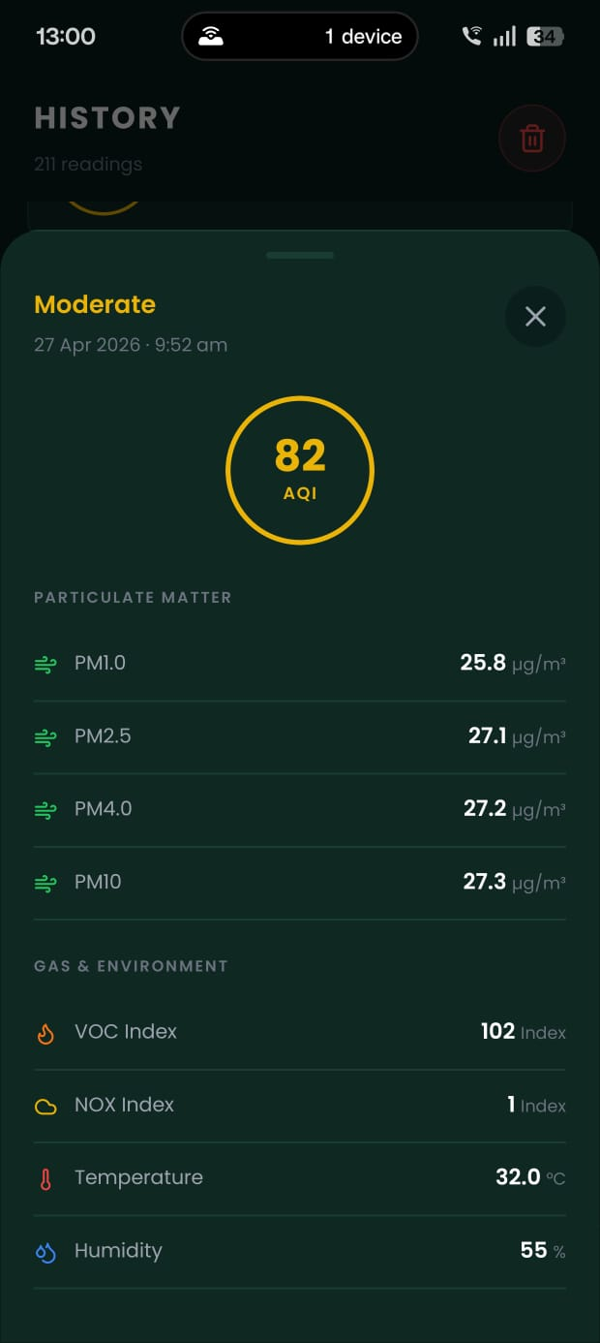
The user interface is designed with a strong focus on clarity and usability. Environmental parameters are displayed using intuitive visual elements such as numerical indicators, graphs, and color-coded AQI categories (e.g., green for good, yellow for moderate, red for poor). This design approach ensures that even non-technical users can quickly understand air quality conditions and make informed decisions. The dashboard layout is structured to present critical information prominently, while also allowing users to view detailed parameter values as needed.
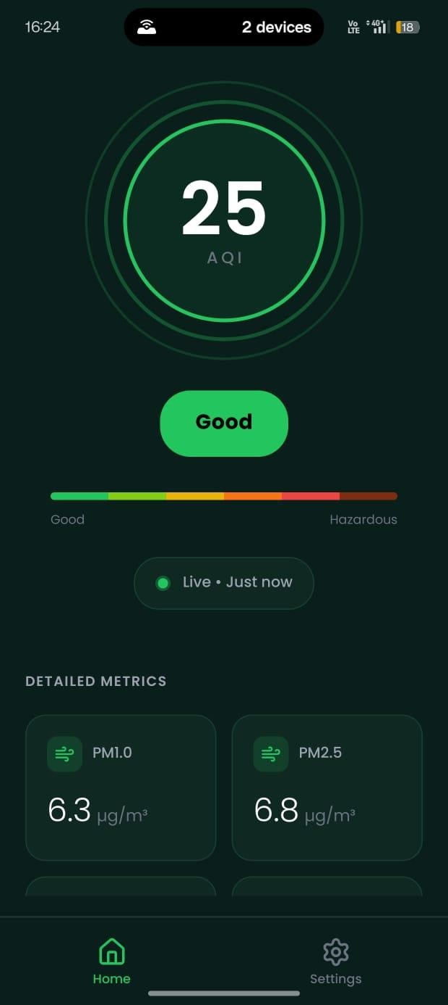
An important design aspect of the application is that it performs no backend or computational processing. All data processing, including AQI calculation and sensor data interpretation, is handled entirely by the embedded system. The application functions purely as a visualization and monitoring tool, which simplifies its design, reduces processing overhead, and ensures faster response times. This also enhances system reliability, as the application does not depend on complex backend services or cloud-based computation.
Figure 7.2 Mobile Application History Detailed
Additionally, the application architecture supports scalability and future enhancements. Features such as historical data logging, graphical trend analysis, alert notifications for threshold breaches, and cloud synchronization can be integrated without major changes to the existing system. The use of MQTT also allows multiple devices or users to subscribe to the same data stream, enabling shared monitoring scenarios.
Figure 7.3 Mobile Application Dashboard
Overall, the mobile application complements the embedded system by providing a user-friendly, efficient, and real-time interface for air quality monitoring. Its lightweight design, combined with seamless communication and intuitive visualization, ensures a smooth and effective user experience.

Chapter 8:
Coding & Testing
  - Development Environment
The firmware for the system was developed using the Espressif IoT Development Framework (ESP-IDF) in Embedded C, which provides a comprehensive and well-documented set of libraries and APIs specifically optimized for the ESP32 microcontroller family. ESP-IDF was chosen over alternative frameworks such as Arduino due to its superior control over hardware peripherals, task scheduling via FreeRTOS, and its native support for the MQTT and Wi-Fi stack required by this project. PCB design and layout were executed in KiCad EDA, an open-source electronic design automation tool that provided full schematic capture, PCB routing, and Gerber file generation capabilities. The mobile application was developed for the Android platform using standard Android SDK tools within the Android Studio integrated development environment. Version control and code management were maintained throughout the full development lifecycle to ensure traceability of changes across firmware, hardware, and application components.
  - Key Code Modules
    - Sensor Driver Module: Handles initialization and data acquisition from the SEN55 sensor via digital interface, including error handling and retry logic.
    - AQI Computation Module: Implements the linear interpolation formula for each pollutant and returns the maximum sub-index as the overall AQI.
    - Wi-Fi Manager Module: Manages Wi-Fi initialization, connection, and reconnection logic.
    - MQTT Client Module: Handles broker connection, topic subscription, and data publishing using the MQTT protocol.
    - Main Firmware Loop: Orchestrates all modules in the defined operational sequence with configurable sampling intervals.
  - Testing Strategy
Testing was conducted across multiple structured phases to systematically validate both individual component behaviour and overall system performance. Unit testing was performed first, validating individual sensor readings against known environmental conditions to confirm that the SEN55 sensor and its driver module produced accurate and consistent outputs within acceptable tolerance margins.
Integration testing followed, verifying the complete end-to-end data flow from sensor acquisition through AQI computation, MQTT transmission, and final display on the mobile application, ensuring that no data corruption, formatting errors, or communication failures occurred across the full processing pipeline.
System-level testing was subsequently performed across five distinct experimental environments representing a range of realistic indoor deployment scenarios, allowing the system's real-world performance, stability, and responsiveness to be evaluated under varied and representative operating conditions. Throughout all testing phases, results were logged and compared against expected values to identify any discrepancies and confirm that the system met its design specifications.
  - Hardware Revision
During testing, a temporary power regulation issue was identified in the initial hardware revision. This issue was diagnosed and addressed in a subsequent PCB revision. All experimental results reported in this document were obtained after the power regulation fix was applied. The core device functionality remained stable and unaffected throughout the testing process.

Chapter 9:
Results & Discissions
9.1 Experimental Setup
Experiments were carried out to analyse variation in air quality parameters under different environmental conditions. The SEN55 sensor operates with factory calibration; baseline correction was performed using clean ambient air conditions prior to experimentation. All subsequent readings are compared relative to this baseline to observe deviations caused by controlled and uncontrolled pollution sources.

9.2 Average Environmental Parameters
Table 1 summarizes average values of AQI and sensor parameters recorded under five different experimental conditions.

Environment | AQI | PM1.0 (µg/m³) | PM2.5 (µg/m³) | PM10 (µg/m³) | VOC Index
Ambient Air (Baseline) | 145 | 62 | 92 | 145 | 190
Empty Enclosed Box | 125 | 48 | 78 | 120 | 150
Box + 1 Agarbatti | 190 | 95 | 135 | 210 | 260
Box + 5 Agarbatti | 310 | 180 | 280 | 420 | 420
Crowded Indoor Place | 220 | 110 | 165 | 250 | 300
Same Place (No Crowd) | 155 | 70 | 100 | 160 | 200
Table 9.1 Average SEN55 Sensor Readings Under Different Environmental Conditions

From Table 1, it is observed that particulate matter concentration and gas indices increase significantly in enclosed environments with pollution sources. The highest readings were recorded when five incense sticks were burned simultaneously, confirming the sensitivity of the SEN55 sensor to elevated pollutant concentrations.
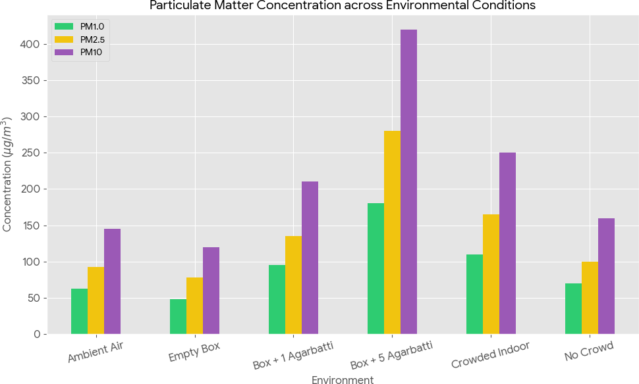
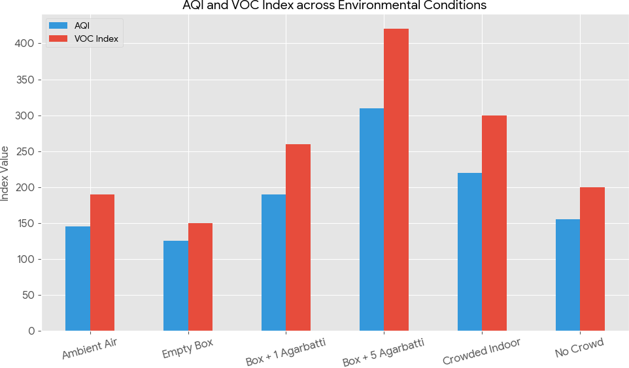
Figure 9.2 Particulate Matter Concentration across Environmental Conditions
Figure 9.1 AQI and VOC Index across Environmental Conditions
9.3 Time-Based Variation of Air Quality Parameters
Table 2 presents the time-based variation of air quality parameters recorded at 2-minute intervals, demonstrating gradual pollutant accumulation in an enclosed environment
Time (min) | AQI | PM2.5 (µg/m³) | PM10 (µg/m³) | VOC Index | NOx Index
0 | 170 | 120 | 190 | 240 | 42
2 | 180 | 135 | 210 | 260 | 48
4 | 190 | 150 | 235 | 280 | 52
6 | 200 | 165 | 260 | 300 | 58
8 | 205 | 175 | 280 | 320 | 62
10 | 210 | 185 | 300 | 340 | 68
Table 9.2 Time-Based Variation of Air Quality Sensor Readings

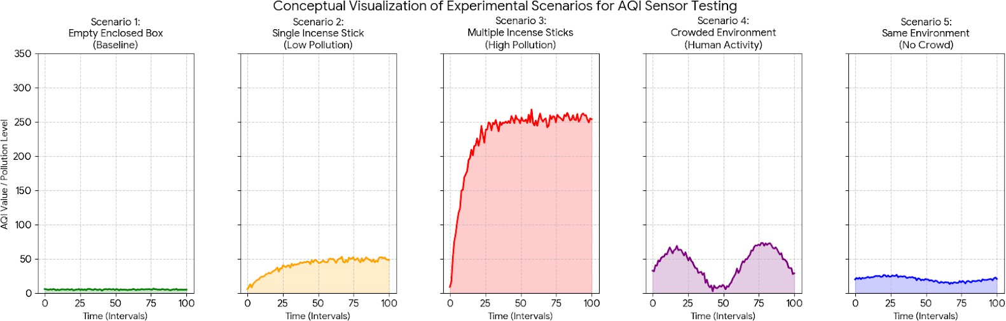
Table 2 confirms a consistent upward trend in all parameters over time in enclosed spaces. This validates the system's ability to track progressive air quality degradation in real time
Figure 9.3 Air Quality Sensor Trends Over Time
Conclusion
In this project, a compact IoT-based air quality monitoring system has been designed, implemented, and evaluated under practical operating conditions. The system was tested across multiple real-world scenarios including ambient outdoor air, enclosed spaces, controlled smoke generation using incense sticks at varying quantities, and crowded versus uncrowded indoor environments. The results confirm that the ESP32-SEN55 based platform is capable of reliably capturing variations in particulate matter (PM1.0, PM2.5, PM10), gaseous pollution indicators (VOC and NOx indices), and environmental parameters in real time. The observed correlation between AQI values and particulate matter concentrations validates the practical usefulness of the system for air quality assessment in regions with high baseline pollution. Wireless data transmission via Wi-Fi and MQTT, combined with on-board AQI processing, enables timely access to air quality information without the need for complex infrastructure. Compared to multi-node and infrastructure-heavy systems reviewed in the literature, the proposed design achieves similar localized monitoring capability with significantly reduced hardware complexity and cost. The proposed system is practically deployable for indoor and near-outdoor environments such as homes, offices, classrooms, and laboratories where localized air quality awareness is essential. With minimal calibration and routine maintenance, the system can support continuous monitoring and early detection of deteriorating air quality.

Future Scope
- Long-term stability analysis and drift characterization of sensor readings over extended deployment periods.
- Calibration of the system against reference-grade government monitoring instruments.
- Integration of CO2 and CO sensors for more comprehensive indoor air quality assessment.
- Development of cloud-based data logging and historical trend visualization features.
- Battery-powered operation for fully wireless, portable deployment scenarios.

References
- D. Zhang and S. S. Woo, "Real Time Localized Air Quality Monitoring and Prediction Through Mobile and Fixed IoT Sensing Network," in IEEE Access, vol. 8, pp. 89584-89594, 2020.
- K. Zheng et al., "Design and Implementation of LPWA-Based Air Quality Monitoring System," in IEEE Access, vol. 4, pp. 3238-3245, 2016.
- L.-J. Chen et al., "An Open Framework for Participatory PM2.5 Monitoring in Smart Cities," in IEEE Access, vol. 5, pp. 14441-14454, 2017.
- Z. Hu et al., "Real-Time Fine-Grained Air Quality Sensing Networks in Smart City: Design, Implementation, and Optimization," in IEEE Internet of Things Journal, vol. 6, no. 5, pp. 7526-7542, Oct. 2019.
- Z. Liu et al., "Multi-Points Indoor Air Quality Monitoring Based on Internet of Things," in IEEE Access, vol. 9, pp. 70479-70492, 2021.
- A. Kumar et al., "Air Quality Monitoring System Based on ISO/IEC/IEEE 21451 Standards," in IEEE Sensors Journal, vol. 16, no. 12, pp. 5037-5045, June 2016.
- S. C. Bhatia, Textbook of Air Pollution and Its Control, Atlantic Publishers & Distributors, New Delhi, India, 2010.
- World Health Organization, WHO Global Air Quality Guidelines: Particulate Matter (PM2.5 and PM10), Ozone, Nitrogen Dioxide, Sulfur Dioxide and Carbon Monoxide, WHO Press, Geneva, Switzerland, 2021.
- Sensirion AG, "SEN55 Environmental Sensor Module Datasheet," Sensirion, Switzerland, 2023.
- Espressif Systems, "ESP32-WROOM-32 Technical Reference Manual," Espressif Systems, Shanghai, China, 2022.

